**Detailed Functional Requirements for the New Direct Deposit Application**

**Validation Process –**

1. **Automated Validation on Bank File Load Completion (BAI2 and CVS)**
   * Download BAI2 and Csv files containing detailed records for debit and /or credit direct deposits and bank summary totals. Detailed records should be processed/validated as detailed below, but the summary totals records should be written to a separate file or control file to be accessed later.
   * Automatically trigger the validation process once the file is successfully loaded without errors.
   * Display progress of the validation process in real-time to the user.
2. **Outcome-Driven Validation Flow**
   * **Load and Validate:** Upon validation completion, generate and display:
     + **Pre-Edit Report:** A summary of failed transactions and reasons for validation failure (see list of messages below). See sample Pre-Edit Report on Page 9.
       1. *Deceased failed records are reported on the Deceased Exceptions Report.*
       2. *Change any occurrence of FUNB DD to Bank DD in the reason code messages.*

|  |  |
| --- | --- |
| *INVALID_DD_NUM* | *Bank DD Number does not match a DD Number in Affinity.* |
| *DD_NUM_BLANK* | *Bank DD Number is blank or all zeroes.* |
| *NO_MATCHING_PATIENT* | *ATP/PML Record does not refer to a valid patient.* |
| *PATIENT_DECEASED* | *Patient is deceased* |
| *DEBIT_AMOUNT* | *Benefit has a debit amount* |
| *NO_VISITS_FOR_PATIENT* | *Could not locate patient visits.* |
| *NO_MATCHING_VISITS* | *A visit could not be located for the responsible payee.* |
| *NO_MATCHING_VISIT_RATE* | *The visiting rate could not be found for the transaction date.* |
| *VALID_RECORDS_STORED_PROC_FAILED* | *The valid records stored procedure could not be generated.* |
| *MULTIPLE_MRUN_STORED_PROC_FAILED* | *The Multiple Medical Record Number stored procedure could not be generated.* |
| *INVALID_RECORDS_STORED_PROC_FAILED* | *he invalid records stored procedure could not be generated.* |
| *WORK_FILE_STORED_PROC_FAILED* | *WORK_FILE_STORED_PROC_FAILED* |
| *INVALID Bank INCOME_TYPE* | *A valid Bank Income Source Type could not be found* |
| *INCOME_SOURCE_MISMATCH* | *No ATP/PML record matches the income source type coming in* |
| *INVALID_REC_ERROR_STORED_PROC_FAILED* | *The invalid errors stored procedure could not be generated.* |
| *ERROR_FILLING_RECORDSET* | *The work file could not be filled properly.* |
| *CANNOT_FIND_INST_CODE* | *Institution could not be located* |
| *FACILITY_MISMATCH* | *Institution code does not match facility code* |
| *INVALID_AFFINITY_DATABASE_NAME* | *The affinity database name provided is invalid* |
| *PERSONAL_FUNDS_ACCT_NOT_ESTABLISHED* | *Personal Funds Account has not been set up for this account* |
| *AFFINITY_DB_ERROR* | *Could not open one of the Affinity Databases* |
| *NO_CURRENT_VISIT* | *Proper Account could not be found* |
| *NO_VALID_RESPONSIBLE_PAYEE* | *No valid responsible payee set up for this DD Number* |
| *DISTRIBUTION_AMTS_EQUAL_ZERO* | *Both Personal Funds and Patient Distribution Amounts equal zero* |
| *NO_VALID_ATP_PML_RECORD_FOR_DATE* | *No valid ATP/PML Rates setup for the required date* |
| *DISCHARGED_ACTIVE_ELSEWHERE* | *Patient active or last active at another institution* |
| *ACCOUNT_NUMBER_BLANK* | *Visit found has a blank Account Number* |
| *TWO_OR_MORE_PATIENTS_WITH_SAME_MRUN* | *Two or more patient's setup with the same MRUN* |

* + - **Deceased Exceptions Report:** A report of transactions linked to deceased patients.
    - **Valid Records File/Report -** transactions that have been validated and will be posted during the next Post cycle.
  + **Load, Validate, and Post:** Proceed directly to the posting process upon validation completion, bypassing reports display.

**Validate Transactions Screen**

1. **Dynamic Validation Screen Behavior**
   * Automatically open the Validate Transactions Screen after file load for immediate validation processing.
   * Append new records from the loaded file to existing records in the work- table for validation.
2. **Validation Rules and Checks**
   * Implement robust validation logic -for each detaileddebit and/or credit record, a systematic query should be done to match the -
     1. ACH ID to the Direct Deposit Number in the legacy system.
        1. Identify if Patient DD# and/or MRUN is reported at multiple facilities.
     2. Locate Patient Account Number
     3. Locate the MRUN
     4. Determine if patient deceased
     5. ,Identify appropriate ATP/PML rates including Income Source; (e.g., income source matching debit/credit records for deceased patients, etc.)
   * “IF” statements are addressed by the HEARTS Team on the workflow diagram.
     1. *IF check net amount received is greater than ATP/PML record total, fulfill the Patient Account amount first and then apply remainder of funds to personal funds.*
     2. *IF check net amount received is less than ATP/PML record total, fulfill the personal funds payment first and then apply remainder of funds to Patient Account.*
   * Move validated records to the **Valid Records Table**.
     1. EXCLUDING DETAILED DEBIT TRANSACTIONS (debit transactions cannot be posted to PA and/or PFS accounts.
   * Place un-validated records in the **Pre-Edit Table** for user review and correction.
   * Place **“debit”** records in the Pre-Edit Table for user review and correction.
   * Place **deceased** records on the **Deceased Exception Report.**
3. **Validation Progress Tracking**
   * Continuously update the user on validation progress using a progress bar or real-time status messages.
4. **View Validated Records**
   * Enable a "View Transactions" button post-validation to display valid records in a grid/report format.
   * Include transaction details like account number, amounts for posting to Patient Accounting (PA) or Personal Funds (PF); Bank Date, Institution, Medical Record Number and, summary records; balance PF and PA columns.
5. **Recursive Validation for Failed Records**
   * Allow users to revalidate records in the Pre-Edit Table through a "Validate Transactions" option.
   * Allow users to edit individual payment details for PA and PF distribution amounts
   * Merge un-validated records back into the worktable; un-validated records “remain” in the pre-edit worktable until validated or moved by user (i.e., hide bank file summary totals, etc.)
6. **Pre-Edit Maintenance Interface**
   * Create a modern, full-screen interface for managing invalid records.
   * Design an intuitive grid view for records, with columns clearly marked as editable or locked.
7. **Editing Invalid Records**
   * Allow users to edit specific fields directly in the grid (e.g., income source, PA & PF distribution amounts) using dropdown menus for valid options.
     1. Excluding the ACH ID # on file from US Treasury
     2. Excluding Facility Location
        1. Exception: If the facility applies for representative status under DSOHF and not individual facility (5016 shows DSOHF)
   * Provide an "Override **"** button to transfer manually updated records from invalid to valid records table after confirmation.
   * Records Overridden manually to “valid records file” bypass normal validation edits.
8. **Recoupment Transactions for Deceased Patients**
   * Enable a Hidebutton for matching debit and credit transactions for deceased patients. *In a situation where the US Treasury debits our clearing account (bank) for a patient that owes money back to the entitlement program, business process is to request a “check” from the facility, deposit that check into our clearing account (bank) and then HIDE those transactions so they don’t continue to show up on the Pre Edit report****.***
   * After check is deposited, these debit and credit detail transactions are hidden and moved to a separate “HIDE” Invalid records grid.
   * No further validation is done on these two records and therefore not returned to the “valid records file.
9. **Hide Invalid Records –** 
   1. Include a **HIDE**” button to mark selected invalid records as inactive (i.e., deceased debit/credit transactions, bank summary totals.)
   2. Display **HIDDEN** records in a separate **“HIDE”** Invalid Records" grid.
10. **Purging (7 years retention period)**
    1. Generate a report for the CBO to review.
    2. Report will include all records.
11. **Returning records to a “in-valid” status (unhide) –** 
    1. **Allow users to restore records using an "Unhide " button.**
    2. Automatically move records back to the Invalid Records Table.
12. **Finding Specific Records**
    1. Include a "Find" dialog for users to search records using column-based filters, case sensitivity, and exact string matching.
    2. Highlight matching records in the grid and notify users when no matches are found.

**Posting Process**

1. **Posting Overview**

* If the user clicks the "Load, Validate, and Post" button and validation ends, the Post Transactions screen will appear, and posting will begin automatically.
* If the user clicks Load and Validate, the post transaction screen will not appear.
* Validate records before posting if the process is initiated manually.
* Post funds to personal funds (PF) and patient accounts (PA) systems.

1. **Validation and Posting Logic**

* Epic to DDS - Epic will send flat files with AXX (Admit/Discharge/Transfer) I/P and O/P level data to DDS that will assist in identifying the patient, patient account number, MRUN and distribution amounts.
* Perform validation on records in the Valid Records Table before posting.
* Use HL7 to post valid DFT records to the EPIC EHR system and confirm with an acknowledgment.
* Use HL7 to post valid DFT transactions to PFS if the PF amount is greater than zero and confirm with an acknowledgement.
* **Handling Errors**: Write failed HL7 records to the Pre-Edit HL7 Table for resolution that is separate from regular Pre-Edit.

1. **Posting Progress Indicators**

* Display a list view summarizing progress, including:
* Total number of records
* Total PA Transactions
* Total PF Transactions
* PA Transactions Sent/Acknowledged
* PF Transactions Sent/Acknowledged
* PF Transactions Posted
* PA Transactions Posted
* Errors during posting to PA and PF.

1. **Reporting and Processing After Posting**

* Display the Direct Deposit Detail and Summary Report on screen post-completion for printing.
* DDS State Treasurer function - add sequence number (obtained from NCFS) and process.
  + Automatically create and email Direct Deposit Receipt Logs (A Logs) and email to applicable Regional Fiscal Offices.
  + Automatically generate and email the OSTMHPA and OSTMHLT summary reports to DIT (Team 91)

**Balancing Process**

1. **Auto Balance DD Screen**

* Display Auto Balance Summary view for reconciliation.
  + If =Difference value = $0.00, select Finish
  + If =Difference value is > than $0.00 the balancing process cannot be completed. Business and ITD will troubleshoot and resolve.
* Update new Beginning Balance after every successful reconciliation.

1. **Automated Balancing Worksheet**

* Display and print the Automated Balancing Worksheet upon completing the balance process.
  + **Worksheet Calculations:**
    - Add Beginning Balance – prior period ending balance (taken from Wells Fargo summary totals record file)
    - Subtract Carryover from previous balance – Sum of Pre-Edit Report and Deceased Exception Report totals as of last automated balancing worksheet
    - Add Total CR/DR – Total credits posted to personal funds accounts and/or Care & Treatment (Affinity) accounts for current day posting process. Net amounts should equal the grand total balance from the Direct Deposit and Detail Summary Reports for the current day
    - Add Total CR/DR from Adjustments – Net wire transfers (taken from Wells Fargo summary totals record file)
    - Equals Ending Balance – Sum of Pre-Edit Report total + Deceased Exception Report Total – Adjusted Ending Balance
    - Add DR/CR amount from pre-edit report – total un-validated deposits from pre-edit report
    - Add DR/CR amount from deceased exception – total un-validated deposits from deceased exception report
    - Equals Adjusted Ending Balance – Adjusted ending balance is Beginning Balance + new credits – wire transfer amount
    - Subtract Wells Fargo Ledger Balance – Most recent Wells Fargo ledger balance (taken from Summary totals records file)
      * Equals Difference – Difference between Adjusted Ending Balance and Wells Fargo Ledger Balance. Should always be $0.00

**State Treasurer Interface**

1. **Deposit Sequence Number (DSN)**

* Validate DSN input:
* Only accept Alpha Numeric entries.
* Prevent duplicate DSNs.
* DSN send date.
* DSN Process date.

1. **EFT through CPS/ITS:**

* OSTMHPA and OSTMHLT files are created in DDS post State Treasurer process and emailed to Team 91. These files identify the total PA amount to transfer to the GL and individual DSOHF banks for any personal funds' deposits.
* OSTMHPA and OSTMHLT are automatically sent to print.
* Allow re-creation and re-sending of prior day’s data.

**Reporting Requirements**

1. **Generate the following reports:** 
   1. Pre-Edit Report: From DD_INVALID_REC table.
   2. Deceased Exceptions Report: From DD_INVALID_REC table, sorted by patient details.
   3. DD Detail and Summary Report: From posted records.
      1. Special Processing Indicators for Direct Deposit Detail and Summary Report:
      2. A – Total Benefit Amount is greater than ATP/PML distribution amount.
      3. B – Total benefit amount is less than total ATP/PML distribution amount.
      4. C – Discharged, but not deceased
      5. D – Deceased
      6. E – Discharged Med Surge Active
      7. F – Discharged Active Elsewhere
      8. G- Days in-house (length of stay)
   4. A Logs – Direct Deposit receipt logs
   5. Automated Balancing Worksheet: From balance process results.
   6. Personal Funds file to Treasure report OSTMHLT
   7. Patient Account file to Treasure report - OSTMHPA
   8. Rejection Report.
   9. Valid record Report.
   10. HL7 Failed Records Report

**Reporting and User Feedback**

1. **Dynamic Reporting**

* Generate Pre-Edit and Deceased Exceptions Reports dynamically post-validation.
* Generate Direct Deposit Detailed and Summary reports dynamically after posting
* Generate Direct Deposit Receipt A Logs and OSTMHPA/OSTMHLT files dynamically after State Treasurer processing.
* Generate Automated Balancing Worksheet dynamically after balancing process completed
* Allow users to download, print or email reports directly from the application.

1. **Real-Time User Notifications**

* Notify users of the completion or failure of validation processes.
* Provide clear, actionable error messages for failed validations.

**Modern Enhancements**

1. **Scalable Architecture**

* Use a web-based interface with a responsive design for cross-device compatibility.
* Support higher transaction volumes and file sizes without performance degradation.

1. **Enhanced Security**

* Implement role-based access controls for editing, validating, and posting transactions.
* Use encryption for sensitive data during processing and storage.
* Allow assignment of denying, granting, and taking away access
* Authentication & Authorization
* Role-Based Access Control (RBAC) for authorization.
* Multi-Factor Authentication (MFA) (Email/SMS-based OTP).
* Session Security
* Auto logout after 15 minutes of inactivity.
* Session hijacking prevention using Http Only & Secure cookies.
* Implement Cross-Site Request Forgery (CSRF) protection.
* Audit & Logging
* Log logins, failed logins, role changes, data access.
* Implement real-time security alerts for unauthorized access.

1. **Improved Usability**

* Streamline navigation with contextual tooltips, user guides, and real-time feedback.
* Use dashboards to provide an overview of validation progress, errors, and resolved transactions.

**Sample Reports:**

Below are DDS Report examples. Each Report should have a Run Date/Time and page of page recorded in the footer.

* **Pre-Edit Report (Error message types are reported in #2 above). See sample below for required column details:**

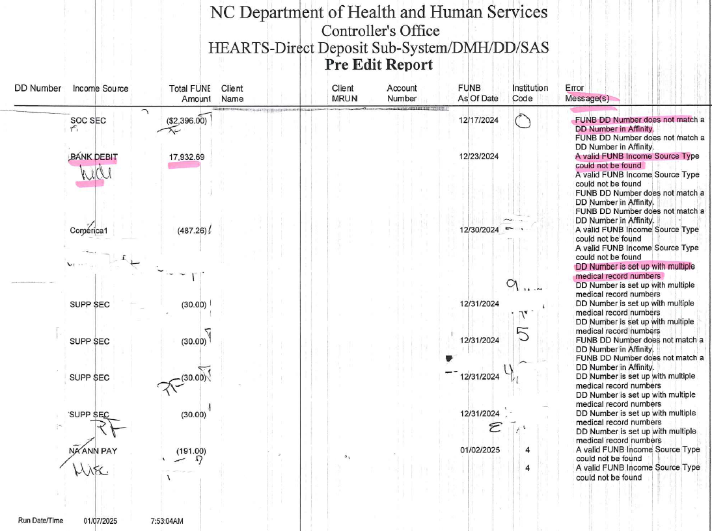

* **Header Record:** 
  + **NC Department of Health and Human Services. Controllers' office. HEARTS-Direct Deposit Sub-System/DMH/DD/SAS. Pre-Edit Report.**
* **Column Details:**
  + **DD Number**
  + **Income source type**
  + **Total FUNB amount**
  + **Client name**
  + **Client MRUN**
  + **Epic Account number**
  + **FUNB as of date**
  + **Institution code**
  + **Pre-Edit Error messages.**
* **Footer: Run date/ time**

* **Automated Balancing Worksheet Report (see #20 above for calculations)**

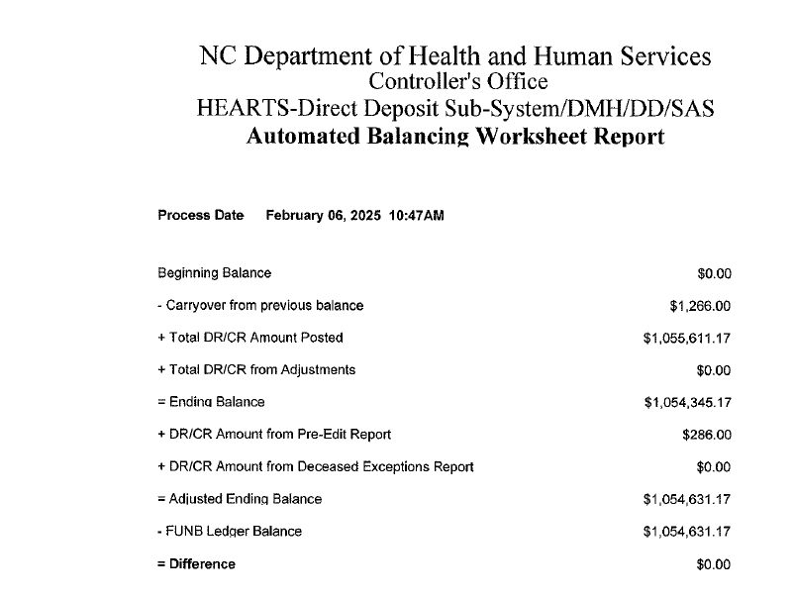

* **Patient Account File to Treasurer Report (Team 91)**
* **Personal Funds File to Treasurer Report (Team 91)**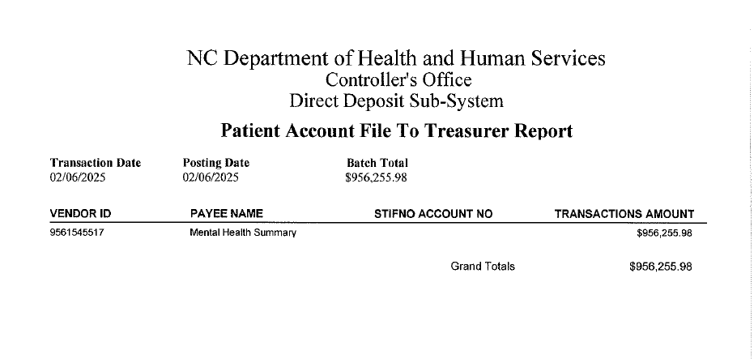

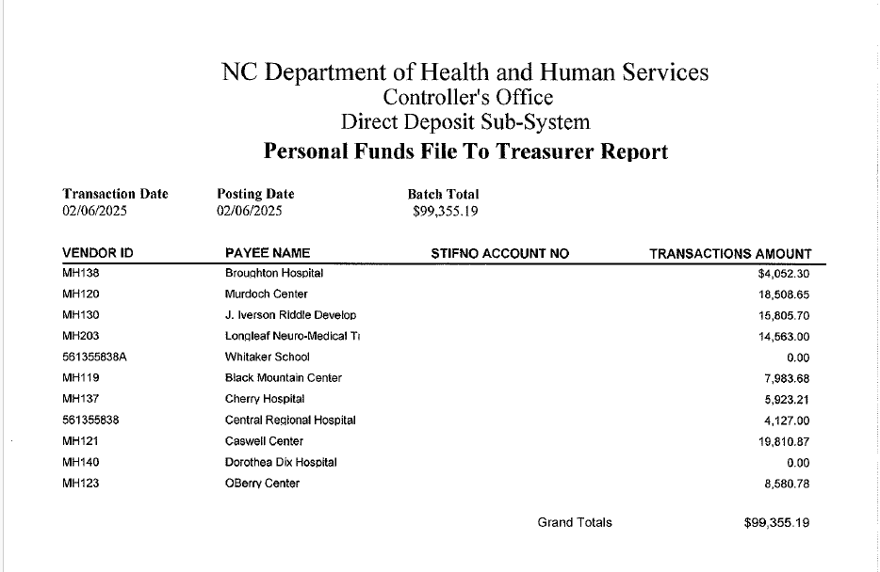

* **Direct Deposit Detail and Summary Report (one report for each facility, example shown is Broughton Hospital. Subtotals for ATP Non-Medicaid and PML Medicaid, Veteran Affair payments, SS, supplemental Income, etc. Etc., Last page of example, page 52 reports a Grand Total of all facilities.)**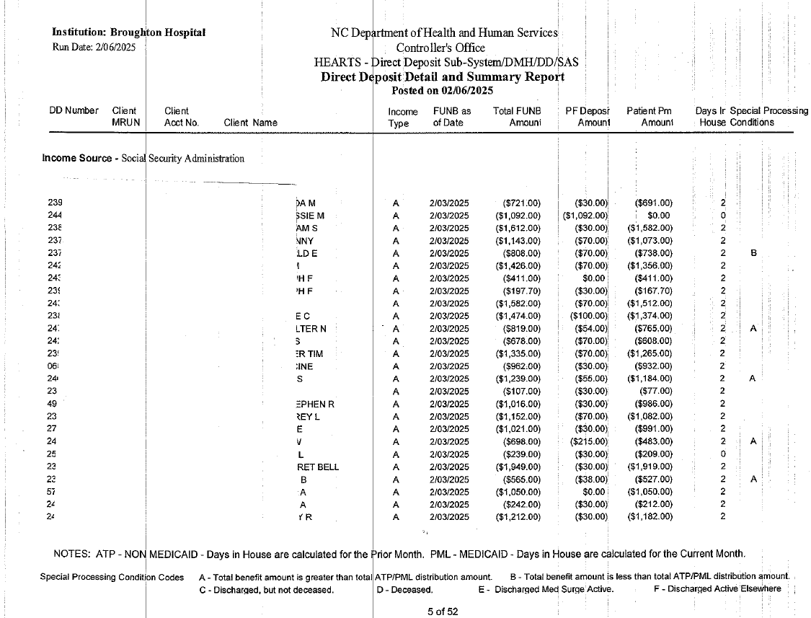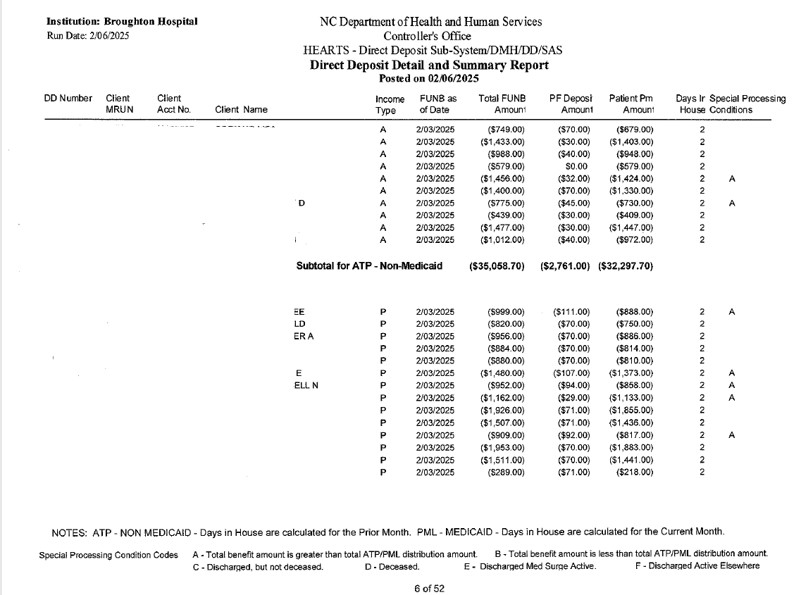

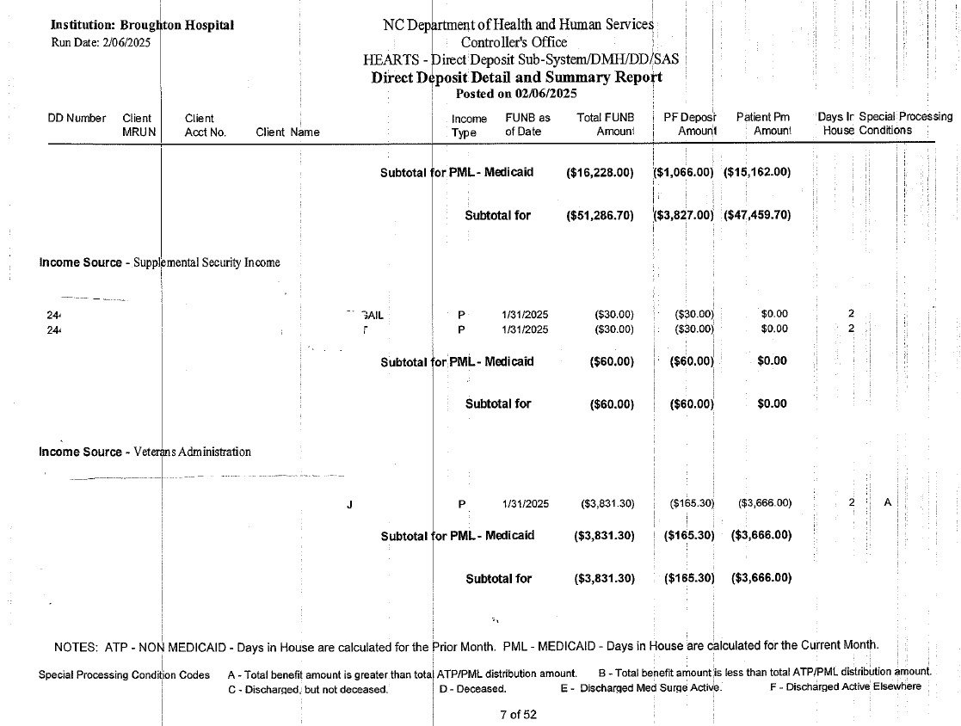

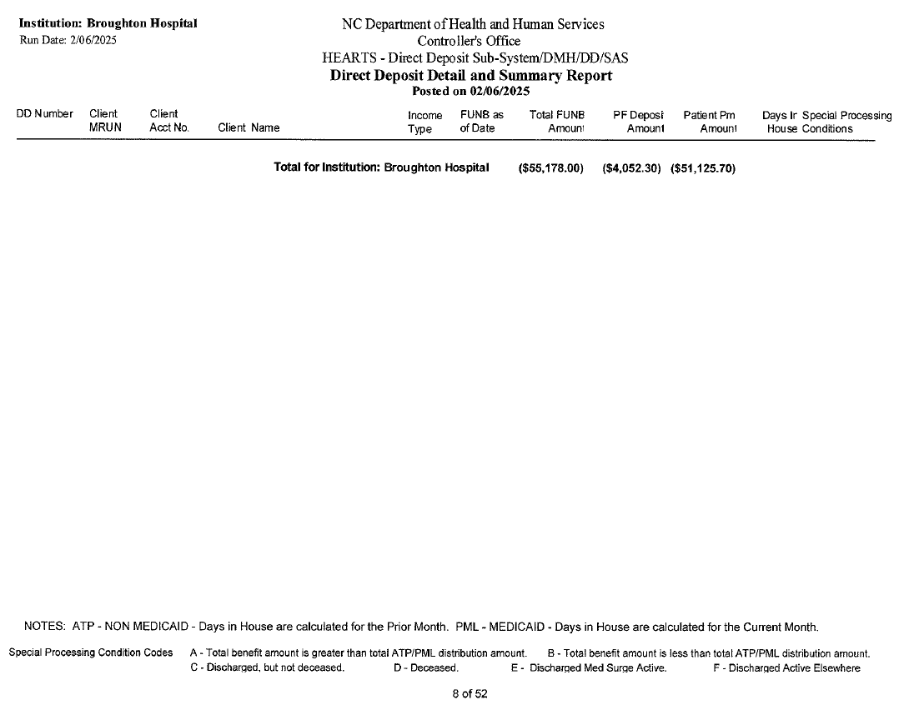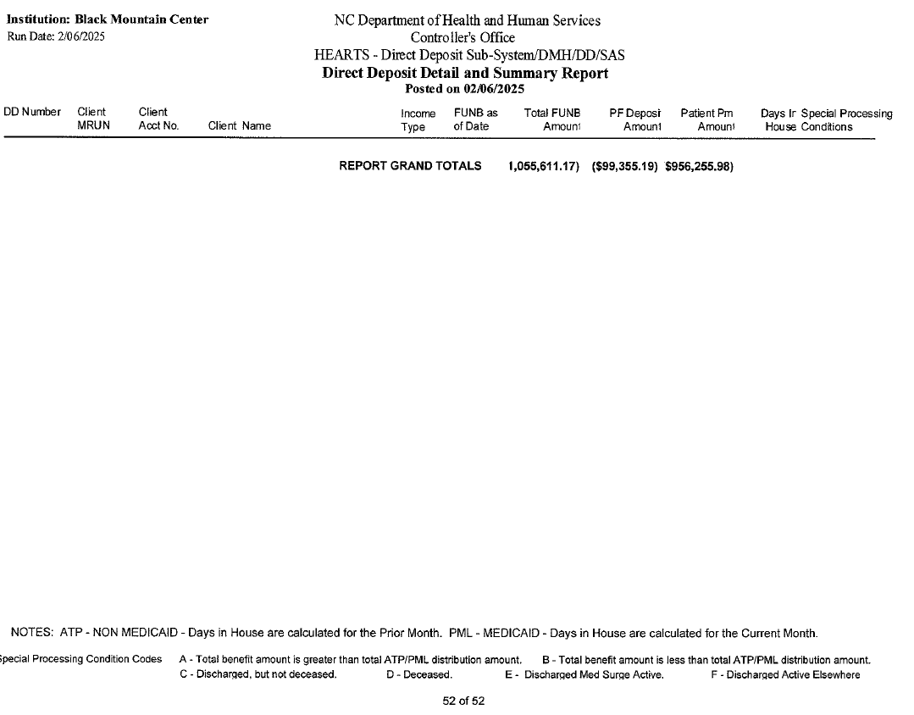

A Logs – Direct Deposit receipt logs

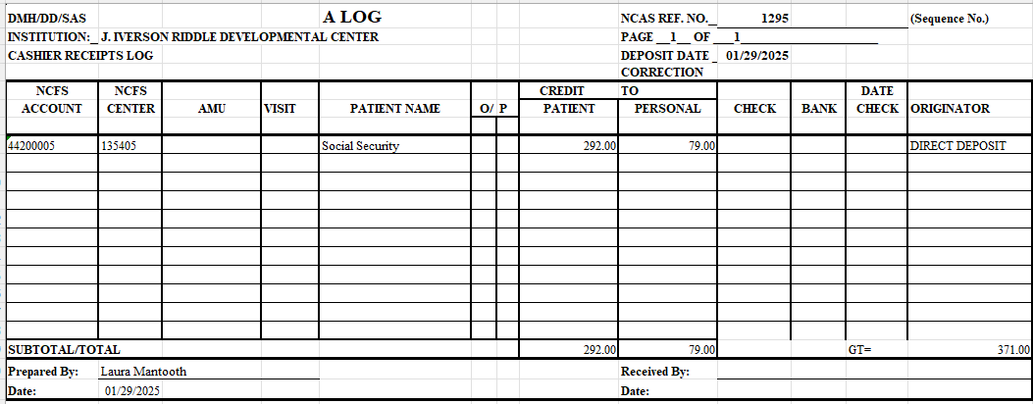

**NEW - VALID RECORDS FILE**

